How-to:
Choose a dogfight maneuver
(Real pilot / artificial pilot)

Mahery ANDRIAMBOLOLONA,
Pascal LEFEUVRE,

Version 1.0
11/03/03

1 Introduction 4
1.1 Context 4
1.2 Overview 4
2 Description of the maneuvers 4
2.1 Principles of Basic Fighter Maneuvers 4
2.2 Maneuvers 6
3 Real pilot reasoning process 9
3.1 Overview 9
3.2 Vocabulary 10
3.2.1 Positional geometry 10
3.2.2 Weapon envelope 13
3.2.3 Pilot Experience - Energy and position principles 13
3.3 Offensive approach 14
3.3.1 Steps to shoot an enemy 14
3.3.2 State machine 16
4 Pilot model 16
4.1 Pilot Model inputs 17
4.2 Interpreting data 19
4.2.1 Position satisfaction rate 20
4.2.2 Energy difference rate 21
4.2.3 Risk rate 22
4.2.4 Reliability rate 22
4.3 Outputs 23
4.4 Missing skills 24
4.4.1 Maneuver Initial conditions 24
4.4.2 Maneuver Technical information 24
4.4.3 Assessing a maneuver destination location 24
5 Conclusion 26
6 GLOSSARY 27
7 Bibliography 28
8 Links 28

Introduction

Context

This work belongs to the project “implementing a bot for a flight simulator”. It should be remained that the first step is to implement a simple dogfight prototype within the end of March. The goals are:
- Getting used to fighter piloting environment.
- Getting used to Artificial Intelligence issues.
- Providing a definitive proposal for the Flight simulator bot.

Overview

This document aims to present what information has been collected about the real pilot making decision process. It also tries to provide some precise ideas about the way the attacker pilot model can take inputs to choose the most accurate maneuver to perform.

It starts giving an overview of dogfight context: the first chapter provides a quick description of some common maneuvers used. The second chapter presents the principles used by a real pilot to choose the most accurate maneuver. It also deals with the steps followed to intercept the opponent. In the third chapter, some clues about the pilot model are suggested to make it as close as possible from a real pilot behavior.

Description of the maneuvers

Principles of Basic Fighter Maneuvers

This section deals with principles of Basic Fight Maneuvers. There are presented out of any tactical context. Besides, fight maneuvers are designed for tactical purposes. They are the topic of the next section.

- Roll
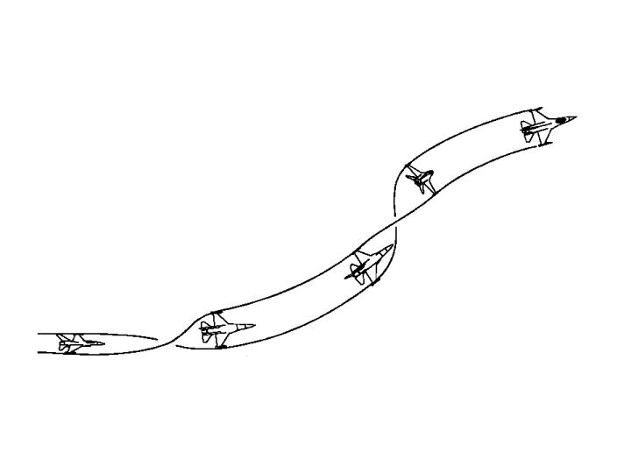Figure 1: roll

Roll is a basic aircraft movement. It consists in rotating along the longitudinal axis. That is this line that extends along the fuselage from nose to tail. As Rolling allows the pilot to position his lift vector, it enables to slow the forward velocity of the aircraft -The lift vector is a vector that sticks directly out of the top of the jet, perpendicular to the aircraft's wings.

- Turn

It is one of the bases of aircraft maneuvers. Some features are crucial when a pilot performs a turn: he must take the corner velocity into account. The corner velocity is a range of 330-340 KCAS airspeed at which the maximum allowable aircraft G and minimum turning radius can be generated. In a few words, it is a range at which the aircraft turn performance is the highest.

- Acceleration

When you pilot your aircraft, accelerating is a basis. The purpose is to increase distance from an object. The aircraft attitude determines the effect of gravity on acceleration. If the aircraft velocity vector is above the horizon, acceleration effectiveness is reduced. If velocity vector is below the horizon effectiveness is enhanced. Moreover, the fastest airspeed gain occurs when you are to 0 G. The speed you go influences your acceleration rate. It is the best in the speed range from 300 to 400 KCAS. The altitude at which you fly impacts the acceleration. The higher the aircraft flies the more effective the acceleration is because of increased thrust.

Maneuvers

- Barrel roll
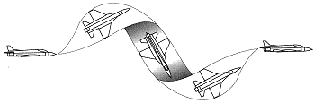
Figure 2: barrel roll

The maneuver name comes from the flight path the aircraft performs as the aircraft rolls round a central axis. It is a speed-consuming maneuver. When a barrel roll is initiated, the aircraft starts performing a spiral. Therefore it increases the through air distance between the aircraft and the point to be reached. Because of the speed loss, it takes more time to go from one point to another one.
- Offensively it is used to prevent overshooting (because of speed loss)
- Defensively, it is used to cause overshooting (because of speed loss)

- Lead Turn
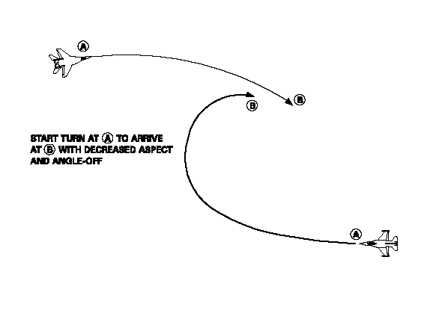
Figure 3: lead turn
Two aircraft are facing. The lead turn aims at positioning the attacker in the opponent six hours. In a few words, the attacker initiates a turn before passing the 3/9 line so that it can reduce the angle between its fuselage axis and the opponent’s nose axis. It can be performed in any plane.

- Split-S

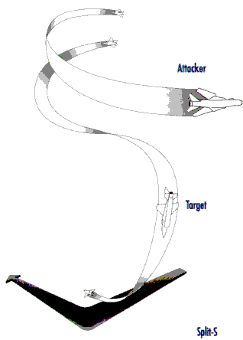
Figure 4: split S
The Split-S is a diving half-loop. Therefore, it is used to increase speed or bleed off altitude. It is a high altitude maneuver (be careful of your height). The Split-S is useful when you want to disengage a threat. Offensively, it is used to proceed a vertical lead turn (high to low).

- Immelman
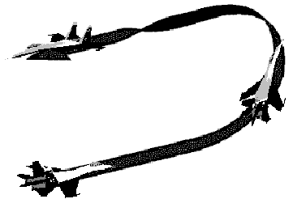
Figure 5: Immelmann
Immelman is neither an offensive nor a defensive maneuver. It looks like a half loop. It exchanges speed for altitude and reverses direction. Offensively, it can be used to proceed a vertical lead turn (low to high).

- Break Turn
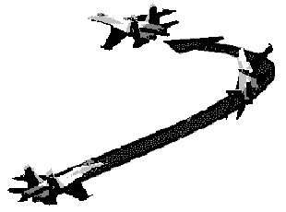
Figure 6: Break turn
The break turn results in a tight turn with high roll angle. It is a defensive maneuver used to avoid a missile or to deny the bandit weapon employment opportunity when he stands in your six. The point is to create as much angle as you can on the bandit. The break turn is high energy consuming.

Real pilot reasoning process

The point of this chapter is to provide some key information about the way a fighter pilot decides which maneuver he has to perform in a dogfight. These clues have been taken from a real F16 handbook downloaded from the Internet. In this document [1], the pilot reasoning process has been analyzed. This analysis will be discussed from the following perspective: trying to extract some good rules of thumb about when to perform such a maneuver in order to automate such a making decision process. Some ideas about the process automation will be the topic of the chapter 3.

Overview

A combat maneuver consists of positioning your aircraft in order that the enemy is in your weapon parameters. But it is also vital to keep your enemy from employing his ordnance against you. Maneuvering your aircraft is the ultimate step of an iterative and complex process of reassessment: observing, predicting, and maneuvering. The final step is a kill or disengagement.
To execute theses tasks, a pilot is required to keep in mind some crucial information:
- Both aircraft characteristics
- Enemy maneuvers
- Energy state of both aircraft
- Its weapons range
- Pilot proficiency
- Both aircraft positions
- Maneuver risks

These parameters can be easily classified:
- Positional geometry (both aircraft position, angles, range)
- Weapons envelope (weapons range, angle required to shoot)
- Pilot Experience (Pilot proficiency, Both aircraft abilities, abilities to assess the enemy’s maneuvers, maneuver risks)

These notions must be defined before dealing with the attacker approach.

Vocabulary

Positional geometry

When speaking about an aircraft’s position relative to another, a pilot deals with range, aspect angle and angle-off. A pilot uses these parameters to evaluate whether he has a position advantage.

Range is the distance between two aircraft.

Aspect angle describes the relative position of the attacker to the target, without regard to the attacker's heading. It is defined as the angle measured from the tail of the target to the position of the attacker.

Angle-off is primarily concerned with the relative headings of two aircraft. Angle-off is defined as the angular distance between the longitudinal axes of the attacker and the defender. Whenever the attacker is pointing at the defender, the aspect angle and angle-off will be the same.
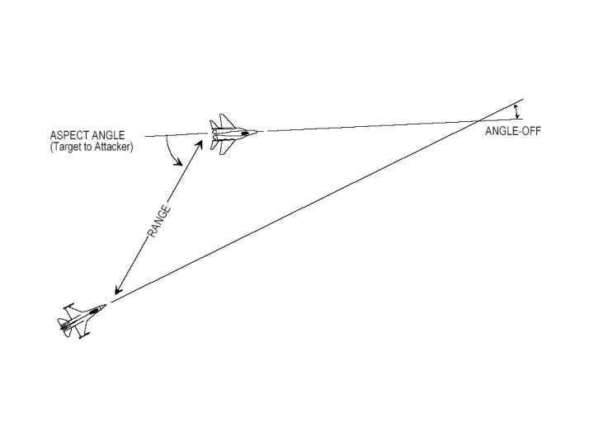
Figure 7: position geometry

Generally speaking, it can be assumed that the closer you are from your target the better your chances are to shoot it down. The less angle problems there are (small aspect and angle off), the closer the attacker is to the ideal shooting position.

All the previous concepts can be merged to give more tactical oriented notion. A pilot visualizes the two aircraft separation in terms of turning room. Turning room is the offset or distance from the bandit. Turning can be acquired in either the lateral or vertical planes or a combination of both. In order to understand the concept of turning room, turning circle should be introduced.

Turning Circle is a concept involved in the approach maneuvers executed by an attacker. Turn circle is simply the defender’s path that an attacker cuts through the sky when the defender turns. The first goal of an attacker is to enter into its opponent’s turning circle. Once in the defender’s turn circle, the attacker can initiate a direct pursuit to position into its opponent’s vulnerable cone.

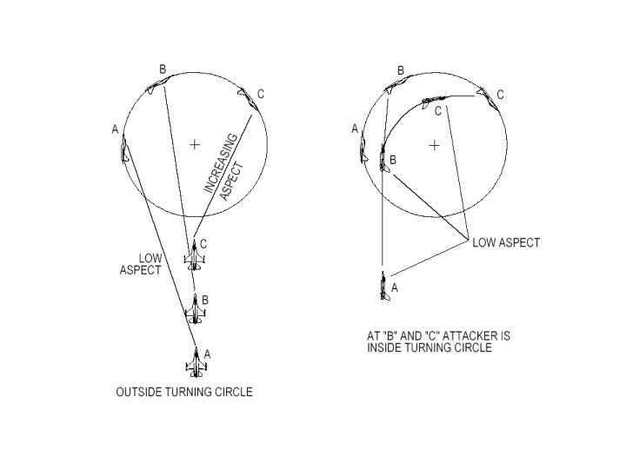
Figure 8: turning circle

When tracking an opponent, an attacker aircraft’s nose position can be three different ways: its nose can point in front of the defender, closure rate increases, it is called lead pursuit. Behind the defender, closure rate decreases: it is lag pursuit. In both cases, angle-off increases. If it points at the adversary it is pure pursuit.

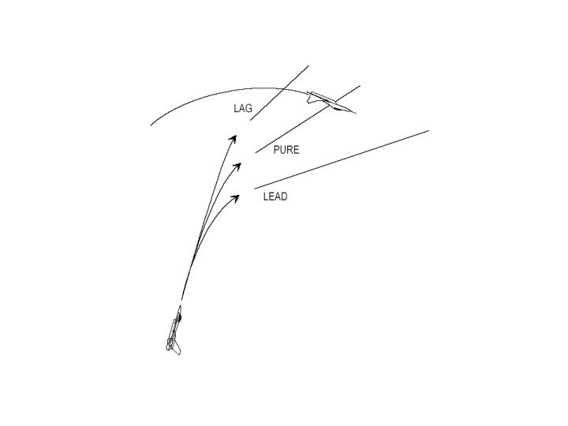
Figure 9: attack pursuit courses

According to angles and range, a pilot elaborates its sequence of maneuvers. Reassessing the turning room he modifies it. The way the pilot takes these parameters into account is the point of section “Offensive approach”. Besides as the Artificial Dogfight player is required to be as close as possible from a real dogfight pilot, the pilot model will also use these criteria in order to choose a maneuver.

Weapon envelope

The weapon envelope is the area around the bandit where your missiles or gun can be effective. These weapon requirements impose a maximum range, aspect and angle-off and pursuit course. That defines the notion of vulnerable cone of the opponent.

The gun weapon envelope is a circle around the bandit depicting the gun's maximum range. There is no minimum range circle.

Pilot Experience - Energy and position principles

The pilot game plan is established by following a principle acquired through practice: the constant balance between energy and position advantage.

Energy is composed of kinetic energy (speed) and potential energy (altitude). Maneuvering consumes energy. When you have more energy than your opponent you have a serious energy advantage on him. When you are maneuvering, you consume energy and there is a constant trade off between speed and altitude.

Besides, the ultimate purpose of an attacker pilot is to position his aircraft in weapon parameters. When you are in your opponent’s six hours, you definitely have a positional advantage. A good pilot should ask this question. How much energy or future maneuvering potential can be expended for a given positional advantage? That is why a pilot must constantly balance energy and position.

As solution, fight maneuvers have been designed to achieve weapon parameters within the minimum energy expenditure in the minimum time as possible.

Offensive approach

In this part it will be shown how the pilot’s behavior during dogfight (especially with guns) can be logically analyzed and organized for later use.

Steps to shoot an enemy

Here follows the state description in which it is liable to be when trying to gun an enemy.
- Outside the Turn Circle: entering it
One of the main issues when dog fighting is entering the opponent’s turn circle (TC). Actually, as long as you stay outside his TC, the aspect angle will increase and you will not be able to use ordnance.
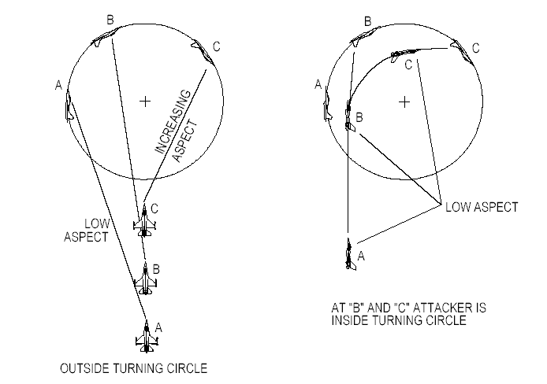
Figure 10: entering turn circle
- Inside the Turn Circle
The goal is now to solve the problem that has been created while transitioning TC: angles, range, speed etc. That is to say to place the aircraft in a position where ordnance can be employed. The maneuvers to be executed depend on what the bandit is doing (type of defense, maneuvers…). Mainly, there are two types of defense:
- Check & extend: the enemy ends his turn and accelerates to increase range and his energy. Consequently the attacker may find himself outside the TC. Thus he should again enter the TC.
- Continuous turn: the enemy wants to create angle problems, and bleed down the attacker’s energy.

- Closing for guns
That represents a state when all is made to place the aircraft in gun position. Closing for guns means also small range and speed. Two main strategies are provided when trying to get in firing position:
- Pull lead: try to maintain a lead pursuit and gun the enemy.
- Bid to lag: it consists in depleting enemy’s energy before gunning him. The principle resides in floating back to the enemy’s elbow while he is losing energy. The easiest way to proceed is to ease off of your turn to follow the enemy with a lag.

State machine
The different phases that have just been presented can be incorporated in a state machine that stands for pilot states. To each state corresponds a goal. For instance, when the pilot is “Outside the Turn Circle”, his goal is to “get inside the Turn Circle”. Considering this goal, information about the pilot, his aircraft and the enemy, and depending on the maneuvers he can proceed, he takes a decision to attempt this goal. The information taken into account will be discussed in the chapter 3. The following picture illustrates this state machine, only considering the pilot as an attacker that wants to gun the enemy.
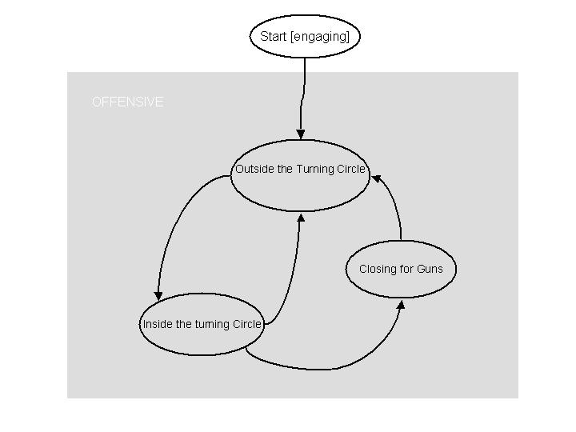
Figure 11: state machine

Pilot model

This chapter closely depends on what was said in the previous one. As it dealt with the real pilot decision process, what follows speaks about the way the pilot model takes parameters in consideration. Of course the main issue consists in doing it so that the pilot model reasons the same way as a real pilot.

It is crucial to notice that only the attacker behavior of the dogfight is modeled.

The point essentially deals with:
- The inputs of the pilot model.
- How inputs can more or less influence the pilot model.

The pilot model process consists of two phases:
  - Looking at the available maneuvers and selecting those that correspond to the context (Event data). A set of event-dependent maneuvers is obtained.
  - Applying the decision process to elect the optimal maneuver.

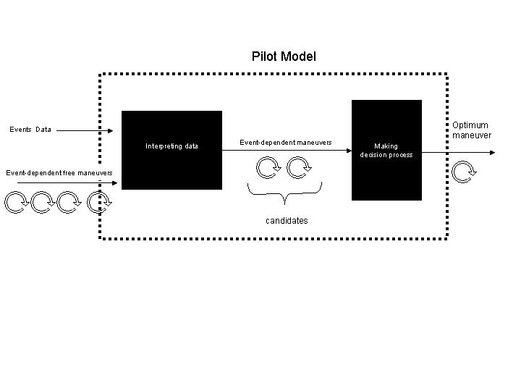
Figure 12: pilot model

This chapter only speaks about the first phase. The algorithms of the decision process itself will not be discussed in this document.

Pilot Model inputs

What follows is about the parameters that the pilot model takes as inputs. In a perfect model, they would be the same as mentioned in the main goal section:

- Aircraft characteristics: it deals with the features of both aircraft. Normally, it really influences the behavior of both fighter pilots, especially when one knows that the other’s turn performance or max speed is higher. Nevertheless, to simplify this first version of the model, it is supposed that both aircraft are the same. Consequently there are no differences in terms of aircraft envelope.
- Energy state of both aircraft: as for a real pilot it is assessed from the aircraft speed and altitude.
- Enemy’s trajectory: Periodically, the pilot has to re-assess the situation to build his game plan. It includes the enemy’s trajectory. Unfortunately as a real pilot, the model is not able to know for sure what maneuver the opponent is currently performing. It has to take former opponent’s locations into account to predict his future trajectory. This trajectory is assessed from the previous and current opponent locations. The following diagram illustrates how assessed trajectories are used.
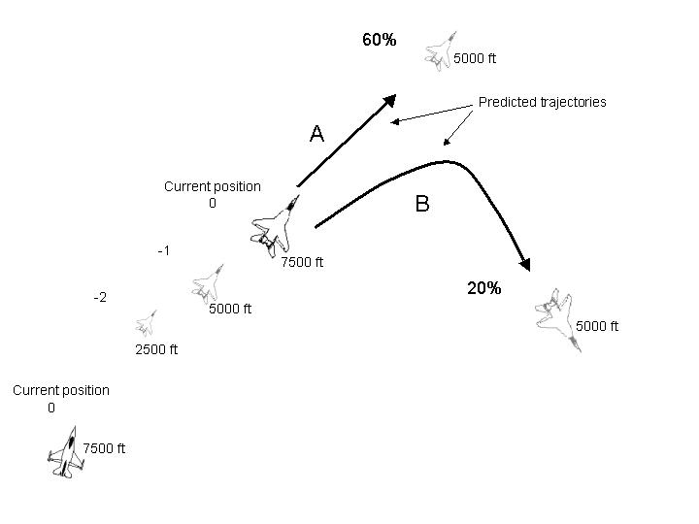

Figure 13: enemy's trajectory
The attacker is in the right and down side corner. He is flying at 7500ft. The altitudes of the defender previous positions are 2500 and 5000ft. Thus, the defender has bled a lot of energy. From current defender’s position, the attacker assesses two paths: a dive from 7500 to 5000 ft (trajectory A) and a turn on the same altitude (trajectory B). The maneuver B is less probable than A because during his zoom maneuver (gaining altitude) the defender depleted a lot of energy. He is not likely to initiate a turn that would probably cost more than a bleed of energy. To perform his next maneuver, the attacker assumes that the defender is about to performing a dive.

- Maneuver knowledge: some maneuver features are independent of the context in which they are performed. There are two different types: the destination location of a maneuver when it is executed in a standard way and the initial conditions required (speed, altitude). Usually a real pilot has acquired this knowledge through practice. The model needs such kind of information to take decisions. Data have been found about initial conditions of a few maneuvers. They are detailed in the “outputs” section. The issue of destination location is dealt further in the “missing skills” section.
- Both aircraft positions: it is assumed that the model has access directly to this kind of information. It is meant relative positions: range, aspect and angle-off.

Parameters | Details | Where from?
Aircraft characteristics | Both attacker and opponent aircraft envelope example | Both aircraft are supposed to be the same.
Energy state of both aircraft | Speed and altitude | Data directly given by the layer below
Enemy’s trajectory | The pilot has to assess what is the opponent’s trajectory to create his game plan. | {Predicted trajectory, probability} provided by the layer below
Maneuver Knowledge | - Potential destination point  - Initial conditions | (See “missing skills” and “available maneuver” sections)
Both aircraft positions | Relative positions of both aircraft. | Data directly given by the layer below

Interpreting data

The point of this section is to give a proposal to the way data can be interpreted by the pilot model. The purpose is to interpret the data the same way as a real pilot would take them in consideration. It is a modeling requirement. In the real pilot making decision process mentioned above: there were the following key words: energy and position advantages, reliability of enemy’s trajectory assessment, maneuver risks. To respect the modeling requirement, these notions should still be used.

The point is the making decision process but the way more importance is given to one maneuver instead of another one facing a given situation.

A pilot should know if a maneuver is worth to perform. That is why he must continually find a balance between position advantage and energy advantage. In the same way, the pilot model has to know how much a situation gives a position advantage or an energy advantage. Thus, the two following rates are computed for the current situation and for each possible maneuver.

Position satisfaction rate

It measures how satisfactory the final position is in term of gun shooting capabilities (it can vary between 0 and 1). Thus this criterion depends on three parameters: aspect angle, angle-off and range. The following diagram shows how each parameter can influence the position satisfaction rate (PSR).
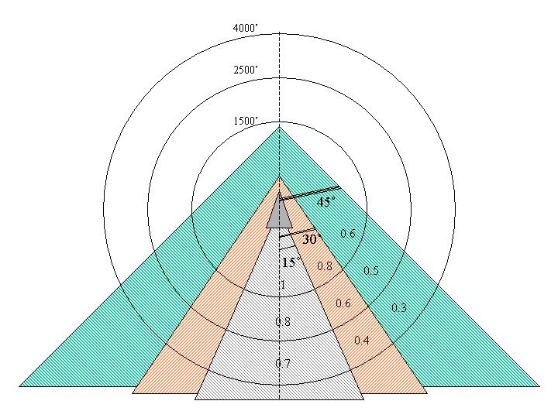

On the diagram, the defender aircraft is assumed to be in the center. As long as aspect angle stays below 45 degrees, your aircraft is close to the enemy’s 6. Thus it is feasible to gun the enemy. Three angle-windows have been considered to point out how aspect angle can influence the PSR:
- Aspect < 15°: The attacker is very close to the enemy’s 6. Thus he must be in pure pursuit. PSR is high.
- 15° < Aspect < 30°: The attacker is far enough from the enemy’s 6 to engage lead pursuit. Otherwise, if he directly points at the target and fires, the bullets will pass behind the target. PSR is still comfortable.
- 30° < Aspect < 45°: The attacker is not so close to the enemy’s 6. Attempts to gun him are not very likely to succeed

The angle-off evolution is related to the aspect one. Depending on the aspect value, the attacker has to point his nose more or less in front of the defender.

Since you need to be close in range to the enemy to gun him in an efficient way, the PSR also depends on the range. This influence can be seen in the diagram. Three range-intervals have been considered:
- Range < 1500 feet
- 1500 < Range < 2500
- 2500 < Range < 4000

The closer to the defender the attacker is, the higher the PSR is. Beyond 4000, range is to high, and the position is not satisfactory.

The model is quite simple. However, it is based on some points of reference that corresponds to diagrams gathered at this website [3]

Energy difference rate

The energy difference rate stands for the energy depleted during the maneuver time compared with the energy consumed by the opponent. If this difference is positive then it is satisfactory. There are two different ways to assess how much energy a maneuver is going to deplete.
- It is supposed that you have enough information about the destination location of the maneuver. You know where the maneuver will lead the aircraft. Thanks to the following formula $ΔE={ΔE}_{k}+{ΔE}_{p}$ where $E_{k}$and $E_{p}$ stand for Kinetic Energy and Potential Energy, it possible to calculate how much energy is consumed.
- It is supposed that you have enough information about the aircraft energy consumption for specific maneuvers. For instance, it is the case concerning the turn maneuver. A Ps chart provided in the Falcon 4.0 handbook shows a series of fluid lines that represent energy states of the F16. It provides numerical data about the F16 abilities to keep energy in different kinds of turn. Of course it depends on speed and turn rate. Unfortunately, such charts are not available for all the F16 maneuvers. Here is the Ps chart mentioned above:

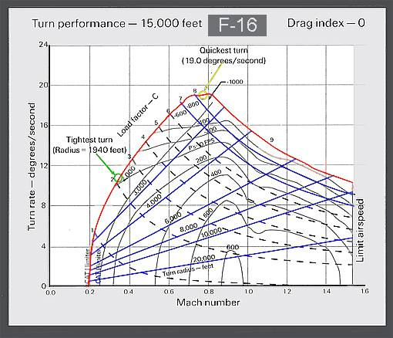

For a given turn rate and speed you can check on the chart if the turn you are performing is an energy-saving or consuming maneuver. In fact, the Ps lines with positive numbers represent where the aircraft has the potential to gain altitude or airspeed.

Risk rate
One of the most important matters for fighter pilot is to keep the enemy from employing his ordnance against him. It is relevant to take these parameters into account:
- Tactical risks
  - How far the opponent is from you vulnerability cone.
  - Minimum Kinetic Energy
- Technical or physical risks
  - Minimum altitude
  - Minimum Range
  - How close to the aircraft limits
  - Pilot capacities.

Reliability rate
Given an opponent’s location, several trajectories can be predicted. Nevertheless, some of them are more reliable than others. Due to the fact that a pilot adapts his game plan to the adversary attitude, it is vital to know if you can trust in the information on which you base your decision.

Outputs

The following chart is based on the offensive approach mentioned above in the previous chapter. These are the different steps that a pilot model has to follow to intercept the enemy. It is presented here in a more formal way than previously so that it can be incorporated more easily in the pilot model.

State | Goal | Tips
Outside the TC | Get inside the TC | - Assess the enemy’s turn circle  - Point to where you want to enter the TC  - Be aware when you enter the TC (more or less aspect angle and angle-off variations)
Inside the TC | Positioning for shooting | - Try to get turning room: the more you have, the easier it will be to proceed maneuvers  - Solve angles and range issues (Lead turn can be used, if enough turning room)  - Always assessing what the enemy is doing: predict his route, his energy…  - If you get outside his TC, enter it again as soon as possible!
Closing for guns | Gun the enemy | - To enter this state the enemy airspeed should be under 250 KCAS  - Aspect angle and range shall not be to sizeable.  - Pull lead or Bid to lag

The following chart sums up the maneuvers that the pilot model could perform to reach the goal mentioned above. These are the maneuvers about which enough information has been collected. For others there was not enough relevant data. For each maneuver, this table also gives some key points to be taken into account when deciding which one to proceed: technical and tactical requirements and the purpose of the maneuver.

Maneuver | Technical requirements | Tactical requirements | Purpose
Lead turn |  | - Offset of one diameter  - Aspect less than 180 degrees | Reduce the angle off and aspect prior passing the 3/9 line, roll behind the enemy
High-G lead turn |  | Short range & little offset
Low-G lead turn |  | Long range, big turning room
Vertical lead turn up | - Speed > 450 KCAS  - Height > 5000’ (10000 recommended),  - MIL power | Significant energy advantage | Same purpose as lead turn, but in the vertical plan
Vertical lead turn down | - Height > 15000’  - Speed 300-350 KCAS  - MIL power. | Enemy low and traveling in the opposite direction. | Same purpose as lead turn, but in the vertical plan
Roll | - Attitude > 10000’  - Speed: 300-400 KCAS  - MIL Power | Speed too high | Prevent a flight path overshoot.

Missing skills

Maneuver Initial conditions

For many maneuvers too few data have been collected, especially about the initial conditions. That is why the pilot model does not take them in consideration.

Maneuver Technical information
For many maneuvers too few data were collected, especially concerning Ps charts. They provide information about how energy consuming a maneuver is. These maneuvers have been dismissed.

Assessing a maneuver destination location
A serious problem is rising while modeling the pilot making decision process. To assess the positional advantage and the energy bleed of a maneuver, it is necessary to have a minimum of information about the destination location of a maneuver.

Before evaluating how much energy a maneuver can cost, it is required to have an idea even vague about its feasibility. Thus it is important to know what are the destination points the aircraft can reach performing such a maneuver.

This set of points will be called destination area. This piece of information need not be very sharp. It is just required to know where approximatively a standard kind of maneuvers can lead the aircraft in a standard environment. (Altitude, speed etc).

For instance, the following graph shows how this destination area is used to determine if it is worth to perform a max G turn that depletes a lot of energy to reach the opponent six. In the case A, the attacker decides to initiate the max G turn to shoot the enemy whether in case B, it is useless to bleed energy as he knows that it is impossible to position.
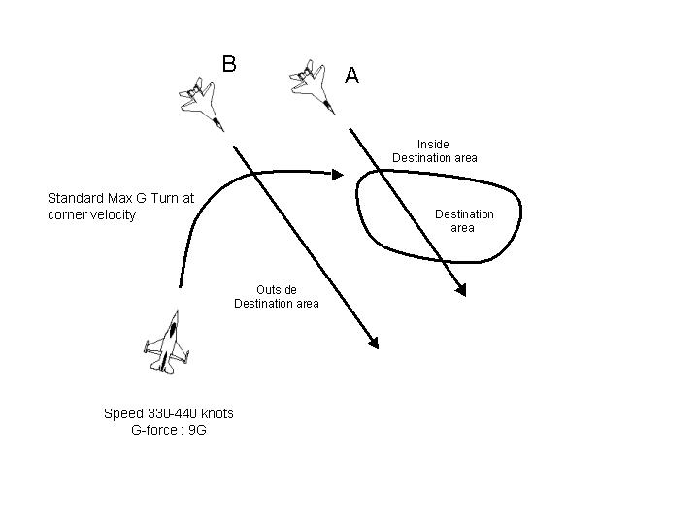
Figure 14: destination area

As it still remains a quickly developed prototype, some solutions have been discussed:

- The destination location of maneuvers can be set considering our own experience. Trajectory can be considered as ideal curve, that is to say all the F16 model constraints will be simplified. Curves will not depend on F16 features.
- Some standard maneuvers can be executed on a F16 flight simulator as Falcon 4.0. Data like destination locations can be logged and used to provide information that look like as closely as possible the reality to the model.

Conclusion

Reading dog-fighting documentation is really time consuming. Before modeling the real pilot behavior, it is compulsory to understand it as well as possible.

Making a pilot model that looks like as closely as possible to a real pilot can be done to a certain extent. Of course the model cannot be as complex as a real pilot. Technically speaking, it must be resource efficient. But the issues encountered especially deal with lack of information. Many technical data about the F16 features are not directly available, probably because there are confidential. Thus it has been necessary to look for information on the simulation community websites and it is still not enough.

Some solutions have been suggested. In the context of the dogfight prototype, missing technical data will be chosen in an arbitrary way. For instance, trajectories will be considered as ideal. Finally, as the main project main purpose is to deal with the AI issues, this choice is logical.

GLOSSARY

Lift vector | An aircraft lift vector is simply a vector that sticks directly out of the top of the jet, perpendicular to the aircraft's wings
Turn radius | It determines the size of the turn circle
Specific power (Ps) | A measure of an airplane's ability to gain or lose energy in terms of altitude, airspeed, or combination of both. Also called energy rate and expressed in feet per second or knots per second
Range. | It is the distance between two aircraft
Aspect angle | It is defined as the angle measured from the tail of the target to the position of the attacker.
Angle-off. | It is defined as the angular distance between the longitudinal axes of the attacker and the defender.
Turning room | It is the offset or distance from the bandit
Turn circle | It is simply the defender’s path that an attacker cuts through the sky when the defender turns.
Game plan | It is a sequence of maneuvers performed during a dogfight.
KCAS | Knots calibrated airspeed.

Bibliography

[1] MULTI-COMMAND HANDBOOK 11-F16, VOLUME 5, 10 MAY 1996, Supersedes MCM 3-3 Volume 5, 1 September 1992

[2] Falcon 4.0 handbook, MicroProse.

Links

[3] The Simulation Community’s Headquarters:
http://www.simhq.com/simhq3/sims/air_combat/f3manual/bfm1.shtml

[4] 87 th Warriors Website:
http://homepage.ntlworld.com/mindmeld/tactics.htm#Basic%20Flight%20Maneuvers

[5] The Federal Aviation Administration:
http://www2.faa.gov

[6] Black Brigade: international military sim com. Unity:
http://www.666th.com

[7] Home of VF-13, the shadow riders.
http://www.vfa-13.com

